

Employers & Resource Providers:

Register now!

Mountain Iron CareerForce Corner Job & Resource Fair

July 16 | 11:30 a.m. - 2:30 p.m.

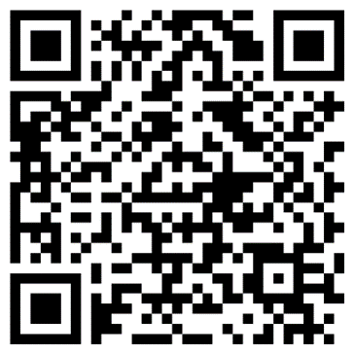
Mountain Iron Community Center | 8586 Enterprise Drive South in Mountain Iron

Snap the code to access the online employer and resource provider registration form

There is NO COST for employers and resource providers to participate in this event

A table and chairs are provided for participating employers and resource providers

Set-up begins 30 minutes before the event
- Event will be promoted to area job seekers via local radio, the CareerForce website and partner websites, GovDelivery emails, the CareerForce job fairs calendar, flyers posted in the community and Facebook and LinkedIn

Questions? Contact Sandra Brick – 612-299-7209 or sandra.brick@state.mn.us

Sponsored by:

